2017-2018 CCMS IMPROV PROGRAM
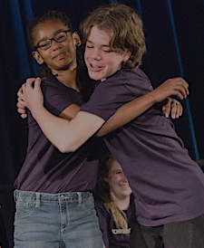
Improv is a comprehensive study of game-based, short form improvisation directed and taught by award-winning professional improvisers, Jennifer Flack & Eric Price. Students learn, practice, and perform basics and fundamentals of improvisation as well as advanced concepts and skills (scene study, character work, styles, genres, and musical improvisation), culminating in a public performance at the end of each semester.
Most importantly, students develop essential life skills such as acceptance, commitment, flexibility, critical thinking, courage, kindness, and authentic collaboration. No experience necessary -- only commitment, adventurous spirit, and positive attitude are required! The CCMS Improv Program is a year-long program.

- Classes are held one day per week (Tue, Thu, or Fri) after school (2:30-4:30).
affordable, year-long
after-school activity
- All students will attend a monthly intensive class @ 4:40-6:15.
- All classes are held at CCMS.

PARTICIPATION IN THE PROGRAM REQUIRES:
- Online REGISTRATION by September 1
- Student attendance at the Sep 7 MANDATORY TRIAL CLASS @ 2:30-4:30 (Room TBA – email will be sent after registration)
(new + returning students are required to attend the Trial Class)
- Parent attendance at the Sep 7 MANDATORY PARENT MEETING @ 4:30-5:30 (Room TBA – email sent after registration)

Registration can be withdrawn after the Trial Class if student/parent decide that the Improv Program is not a good match for student at this time.
Registration is NOT possible AFTER the Trial Class.

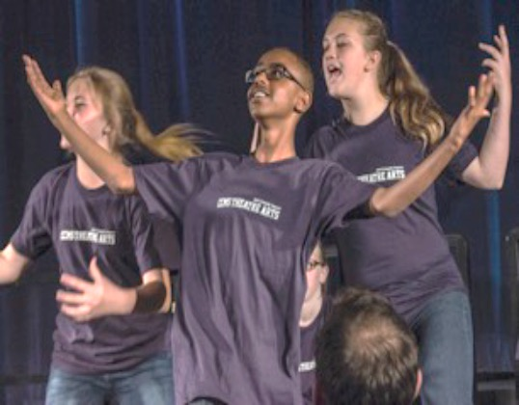
REGISTER ONLINE @ ccmsimprov.com
Details about the program and schedules will be provided at the Mandatory Parent Meeting.
Urgent questions prior to the Mandatory Parent Meeting: ccmsimprov@gmail.com

what parents say about the CCMS Improv Program (anonymous feedback from parents):
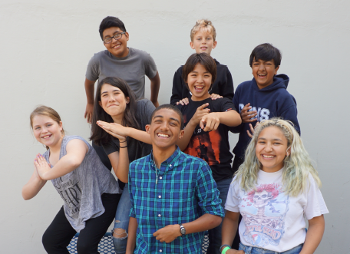
“This group was the deciding factor in attending CCMS!
It is an incredible program to offer our children at this awkward age
– it brings out the best in everyone!”
"I have only positive things to say about this program... my child faced social and emotional challenges
that had him withdrawn, sad and/or angry much of the time. I have seen such a marked change in him since he joined this program.
It has had an amazing impact on my son, and consequently on our whole family!"
“Improv has helped my child to have the confidence & ability to perform academically, particularly when
the unexpected occurs. Practice with performance has enhanced his participation in class discussions and other public speaking forums."
“Improv has been great for my son's personal development. He's learned positive lessons about
having fun, working hard, taking responsibility, working in teams, and being willing to risk failure. It's fantastic!"

